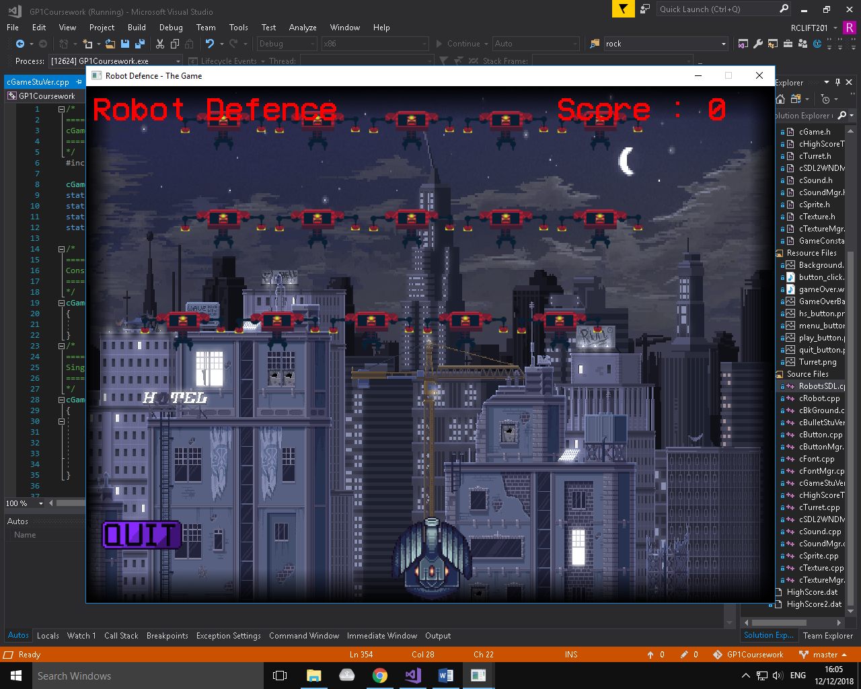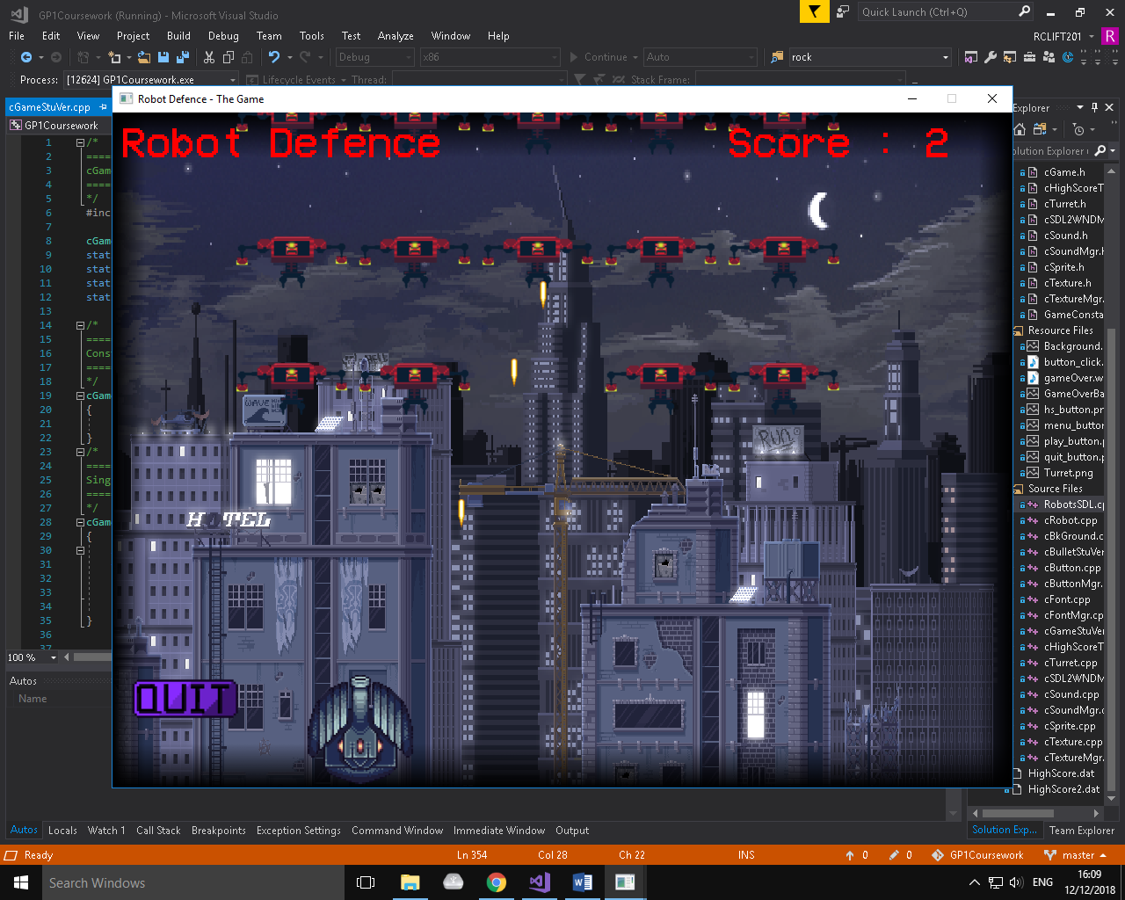

**Game State: In-Game Screen**

Sprites - Quit Button, Enemies (robots), Player (turret), Bullets (lasers), Explosion (when robot is destroyed), Background (city)

Text – Title ‘Robot Defence’, Score (updates by 1 when the player destroys an enemy

SFX – Shooting (laser shot), Hitting Enemies (explosion), Game Over Sound (retro failure)

Music – Retro Music

Buttons – Quit Game (takes the player to the game over screen)

**Game State: In-Game Screen**

Info – The player’s goal is to stop the robots from reaching the city. They have to do this by shooting and destroying them before they reach the bottom of the screen (i.e. the city), through the use of the spacebar. The player is restricted to moving left and right, using the appropriate arrow keys. Whenever the player destroys an enemy robot, their score increases by 1. If an enemy robot reaches the city, the game ends with a retro failure game over sound and the player is taken to the game over screen.